EXNO.6 DRAW RELEVANT STATE CHART AND ACTIVITY DIAGRAMS FOR THE SAME SYSTEM
PROJECT TITLE: Smart canteen management system
DESCRIPTION: STATE CHART DIAGRAM

- The system starts at the Initial State.
- It moves to the Idle State, where it waits for user interaction.
- When the user selects an option, the system transitions to the Menu Display State to show available food items.
- If the user chooses to order, the system enters the Order Selection State, where the user selects the item and enters quantity.
- After input, the system moves to the Order Processing State, where it retrieves price and calculates the total amount.
- If the item exists, the system transitions to the Order Confirmation State, where:
- Order is stored in the database
- Confirmation message is displayed

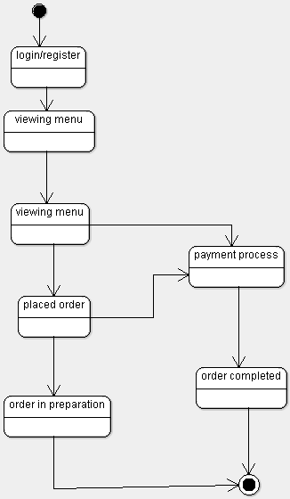

DESCRIPTION : ACTIVITY DIAGRAM
- An Activity Diagram represents the flow of activities in a system from start to end.
- It shows the sequence of actions, decisions, and parallel processes involved in the system.
- In the Smart Canteen Management System, the process starts with the customer logging into the system.
- The customer then views the menu and selects food items to place an order.
- The system processes the order and sends it to the staff for preparation.
- The staff prepares the food and updates the order status.
- The system then processes the payment made by the customer.
- After successful payment, the order is confirmed and delivered to the customer.
- Finally, the process ends after order completion.

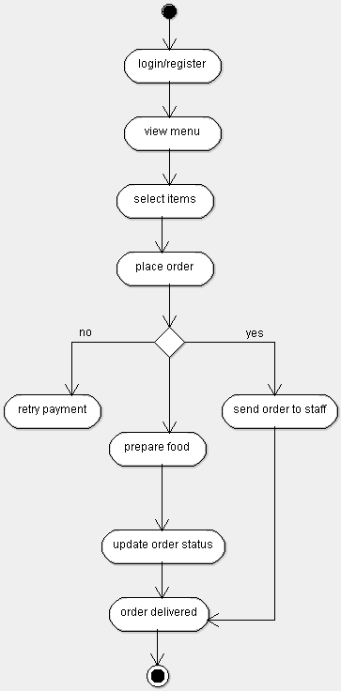

DESCRIPTION : DEPLOYMENT DIAGRAM

- The deployment diagram represents the physical architecture of the Smart Canteen Management System.
- The system consists of a Client Node (User System) where the application is accessed by users.
- The client node runs the Java application interface for menu viewing and order placement.
- The client connects to the Application Layer using JDBC for database communication.
- A Database Server Node is used to store all system data such as menu and orders.
- The database server runs SQL Server, which manages data storage and retrieval.
- The client and database server communicate through a network connection.
- The system ensures smooth data flow between the user interface and the database.
- All order processing and data storage operations are handled by the database server.
- The deployment diagram shows how hardware and software components are distributed in the system.

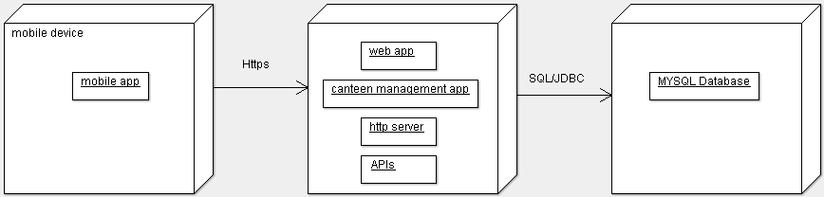

RESULT:
Thus, the Activity Diagram and State Chart Diagram for the Smart canteen Management System were successfully developed to represent the workflow and state transitions of the system.

